Forest plot of comparison: 1 Main Cohort Analysis, outcome: 1.1 Annual Mortality.
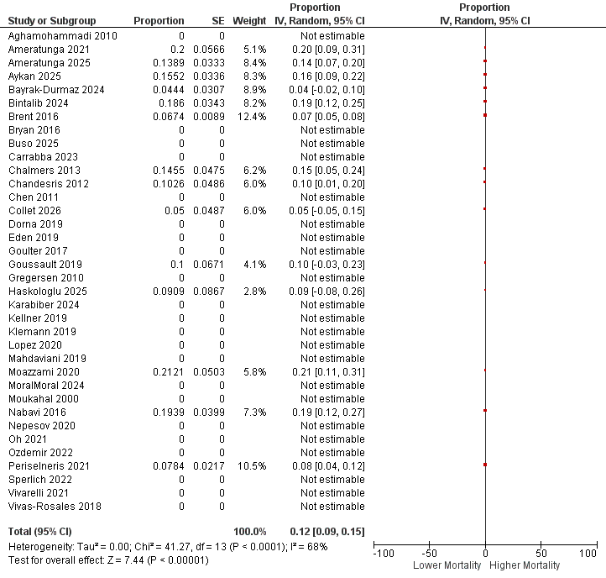
Summary Statistics Table
Statistic | Result
Number of studies | 14
Tau² | 0.00
Chi² | 41.27
Degrees of freedom (df) | 13
P-value for heterogeneity | < 0.0001
I² | 68%
Test for overall effect (Z) | 7.44
P-value for overall effect | < 0.00001

A moderate-to-substantial heterogeneity was observed among the14 included studies (I² = 68%; χ² = 41.27, df = 13, P < 0.0001). The test for overall effect for the studies was statistically significant (Z = 7.44, P < 0.00001).
Forest plot of comparison: 1 Main Cohort Analysis, outcome: 1.2 Yearly FEV1 Decline (mls) [mls].
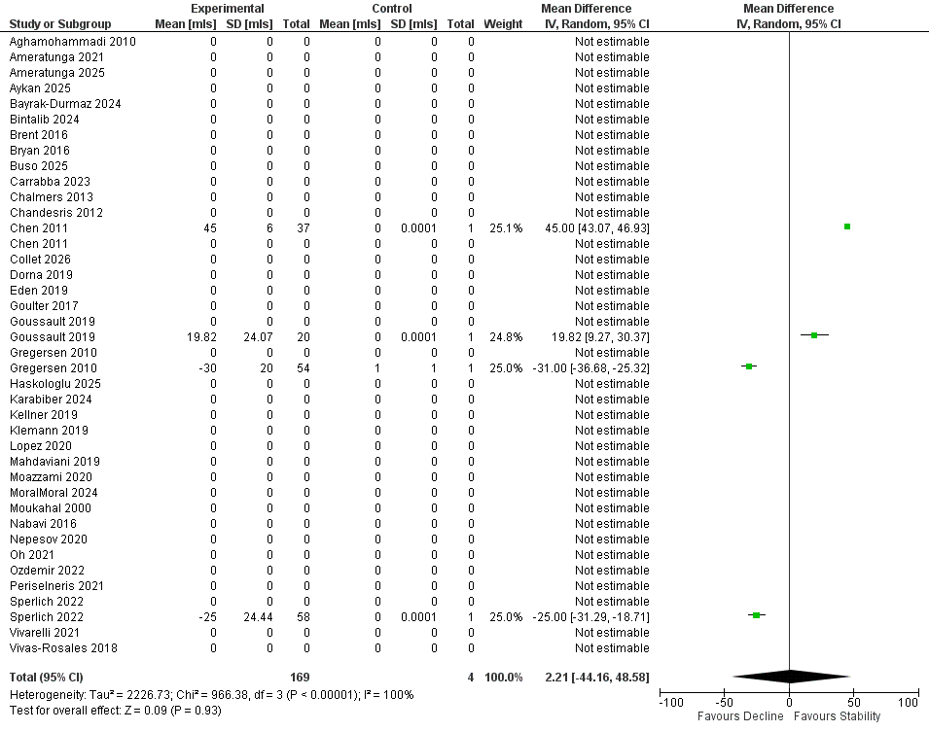
Summary Statistics Table
Statistic | Result
Number of studies | 4
Tau² | 2,226.73
Chi² | 966.38
Degrees of freedom (df) | 3
P-value for heterogeneity | < 0.00001
I² | 100%
Test for overall effect (Z) | 0.09
P-value for overall effect | 0.93

Extremely high heterogeneity was observed among the four included studies (I² = 100%; χ² = 966.38, df = 3, P < 0.00001). There was no statistically significant overall effect in te included studies (Z = 0.09, P = 0.93).

Forest plot of comparison: 1 Main Cohort Analysis, outcome: 1.3 Annual Hospitalisations [Admissions]
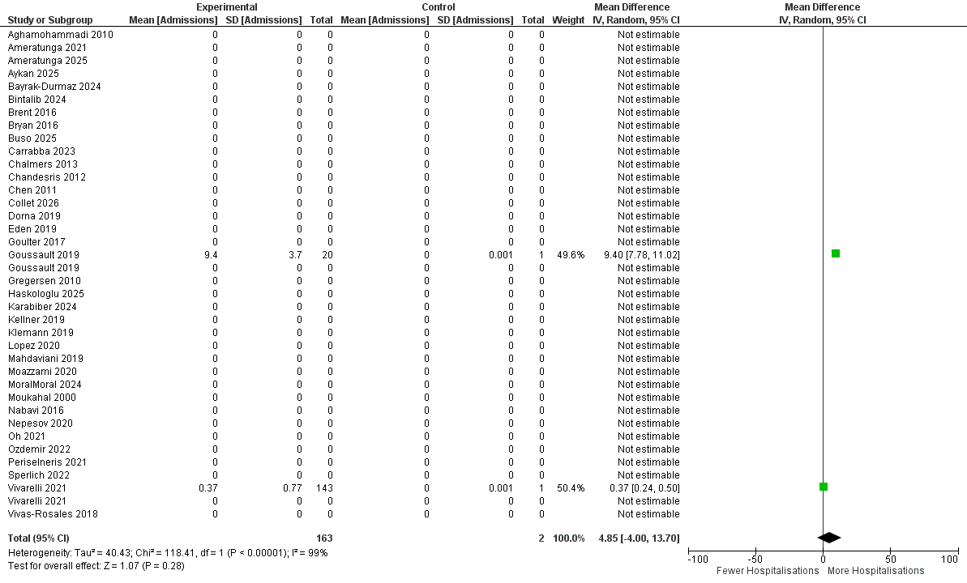
Summary Statistics Table
Statistic | Result
Number of studies | 2
Tau² | 40.43
Chi² | 118.41
Degrees of freedom (df) | 1
P-value for heterogeneity | < 0.00001
I² | 99%
Test for overall effect (Z) | 1.07
P-value for overall effect | 0.28

Extremely high heterogeneity was observed between the 2 included studies (I² = 99%; χ² = 118.41, df = 1, P < 0.00001). The pooled effect was not statistically significant (Z = 1.07, P = 0.28).

Forest plot of comparison: 1 Main Cohort Analysis, outcome: 1.4 Annual Exacerbations of NCFB [Episodes].
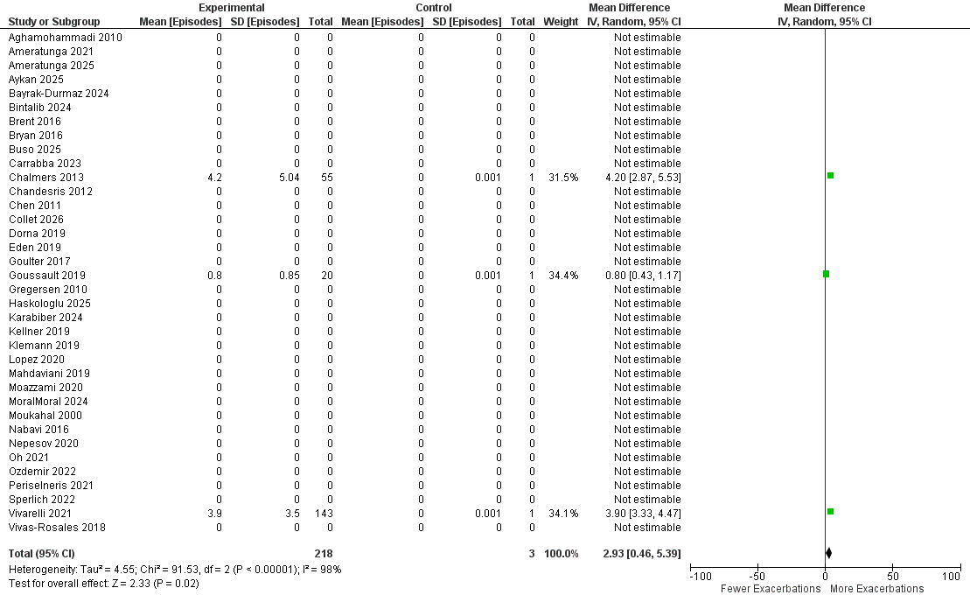

Summary Statistics Table
Statistic | Result
Number of studies | 3
Tau² | 4.55
Chi² | 91.53
Degrees of freedom (df) | 2
P-value for heterogeneity | < 0.00001
I² | 98%
Test for overall effect (Z) | 2.33
P-value for overall effect | 0.02
Effect direction | Fewer ← → More exacerbations
Plot scale | −100 to +100

A very high heterogeneity was observed among the 3 included studies (I² = 98%; χ² = 91.53, df = 2, P < 0.00001). Overall effect for the included studies was statistically significant (Z = 2.33, P = 0.02).

Forest plot of comparison: 1 Main Cohort Analysis, outcome: 1.5 Proportion with Pneumonia.
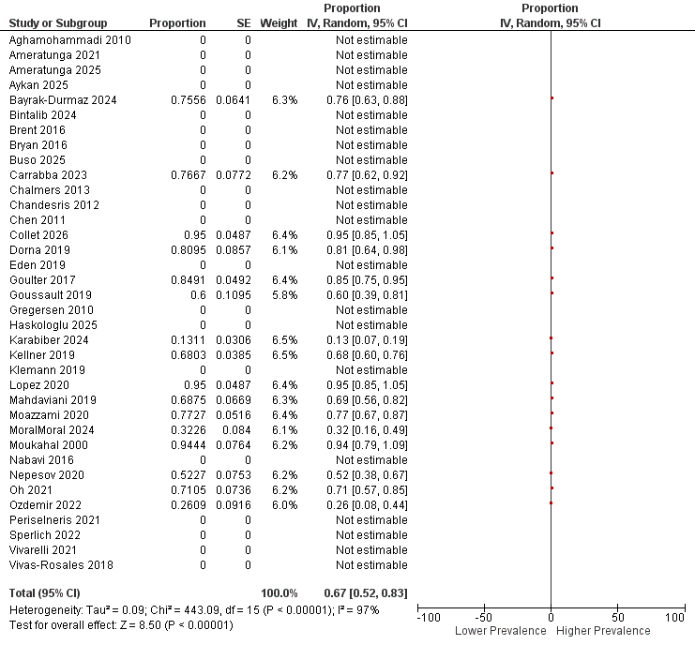
Summary Statistics Table
Statistic | Result
Number of studies | 16
Tau² | 0.09
Chi² | 443.09
Degrees of freedom (df) | 15
P-value for heterogeneity | < 0.00001
I² | 97%
Test for overall effect (Z) | 8.50
P-value for overall effect | < 0.00001
Effect measure | Proportion
Model | Random-effects
Plot range | −100 to 100

There was very high statistical heterogeneity among the 16 included studies (I² = 97%, χ² = 443.09, df = 15, P < 0.00001). The pooled effect was statistically significant (Z = 8.50, P < 0.00001).
Forest plot of comparison: 1 Main Cohort Analysis, outcome: 1.6 Quality of Life.
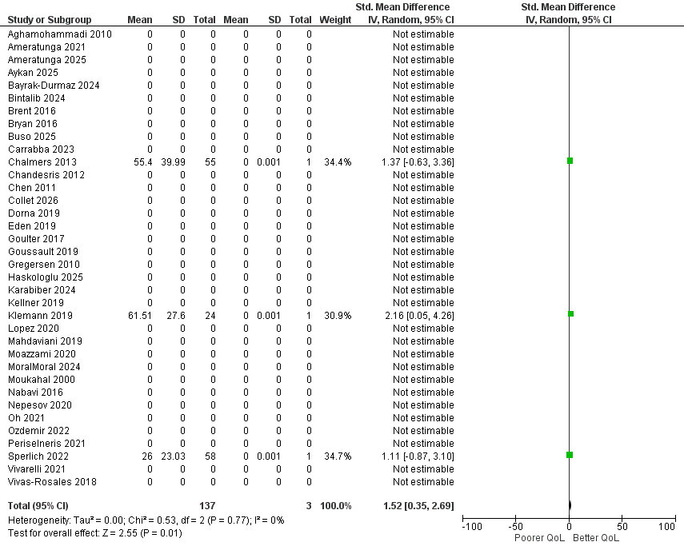
Summary Statistics Table
Statistic | Result
Number of studies | 3
Tau² | 0.00
Chi² | 0.53
Degrees of freedom (df) | 2
P-value for heterogeneity | 0.77
I² | 0%
Test for overall effect (Z) | 2.55
P-value for overall effect | 0.01

There was no evidence of statistical heterogeneity among the three included studies (I² = 0%; χ² = 0.53, df = 2, P = 0.77). The overall effect in the studies was statistically significant (Z = 2.55, P = 0.01).

